Güralp Data Centre software package

Architecture overview

Contents

Architecture diagram 2

Overview 3

Software components 3

IRIS ringserver 3

slinktool 3

Güralp Data Centre controller service 3

Güralp Data Centre Monitor 3

Güralp responder service 5

Communication overview 6

Data Collection 6

Data Distribution 7

Configuration management 8

State of health 9

Summary 10

Network protocols and ports 10

Version 11

# Architecture diagram

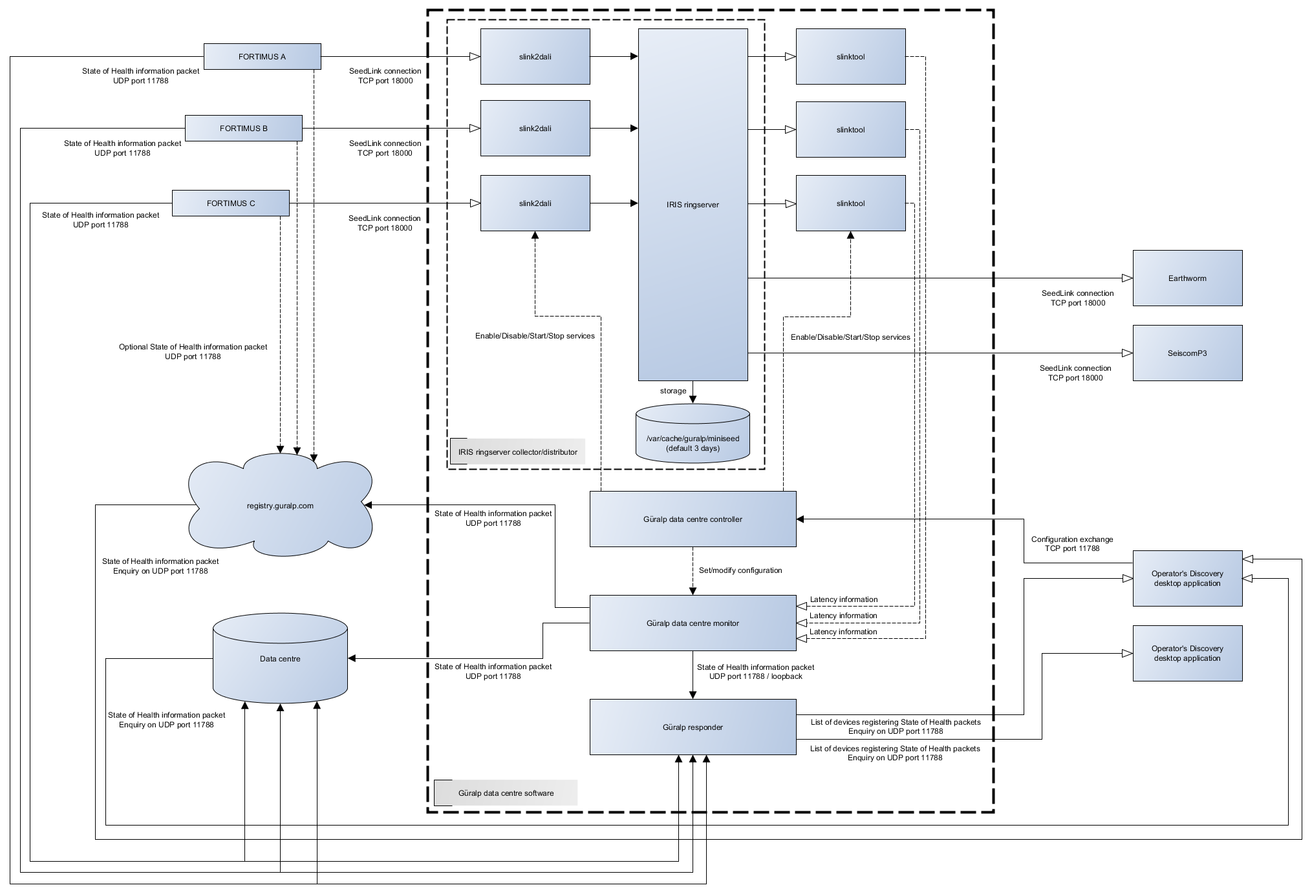

# Overview

Güralp Data Centre software consists of several applications providing system state of health monitoring, data collection and distribution, and remote configuration capabilities. This document describes the software packages provided, explaining the architecture, software components and communication between them.

# Software components

List of all applications included in Data Centre software package:

* IRIS ringserver
* slinktool
* Güralp Data Centre controller service
* Güralp Data Centre monitor
* Güralp responder service

## IRIS ringserver

Ringserver is a well-established stream-oriented packet ring buffer used primarily to transport packetized time series of data. Ringserver supports TCP based protocols: DataLink, SeedLink, and HTTP/WebSocket. The program has a built-in miniSEED archiver and in default configuration provided by Güralp, keeps the data archived for last 3 days.

Configuration details can be found in Güralp Data Centre Operator Manual.

Read more: <https://github.com/iris-edu/ringserver>

## slinktool

Slinktool is used as a diagnostic SeedLink client for latency monitoring. The tool connects to the ringserver and examines the latency of the data packets received. Latency is reported to the system log which is then read by Güralp Data Centre Monitor application and the highest latency value is sent in the state of health packet.

Read more: <https://github.com/iris-edu/slinktool>

## Güralp Data Centre controller service

Güralp Data Centre controller service is a stand-alone application, run as a service, responsible for SeedLink connection management and Güralp Data Centre Monitor configuration. The application communicates with the Discovery desktop application through TCP connection on port 11788 using proprietary protocol in both directions: Discovery-service and service-Discovery.

Service is enabling/disabling and starting/stopping slink2dali and slinktool services responsible for data collection and latency calculation for each seismic station connected to data centre. Additionally, this service modifies the configuration of the Data Centre Monitor with settings configured by the Operator in a dedicated graphical user interface widget in the Discovery desktop application.

## Güralp Data Centre Monitor

Güralp Data Centre Monitor service is a stand-alone application, run as a service, responsible for the periodic sending of state of health packets containing the latest information about Data Centre. State of health packets are sent to selected Güralp responder instances and can be configured by the Operator through either a dedicated GUI widget in Discovery desktop application, or by manually editing the guralp-monitor.ini configuration file.

The configuration file is located in /var/cache/guralp/guralp-monitor.ini and contains pairs of key-value entries:

|  |  |  |
| --- | --- | --- |
| **Key** | **Description** | **Type** |
| registry_addresses | Comma separated IP addresses of Güralp responder servers to which the state of health packet should be send to | Comma separated list of strings |
| registry_group_id | Güralp responder server group identifier string used | String |
| filter_monitored_channels | SEED globing style filter for channels activity monitoring | String |
| filter_monitored_latency_channels | SEED globing style filter for channels latency monitoring | String |
| monitoring_period_latency | Period of time in seconds that should be used to find the highest data latency | Integer |
| monitoring_period_active_channels | Period of time in seconds that should be used to detect number of active channels | Integer |
| monitoring_period_active_devices | Period of time in seconds that should be used to detect number of active devices | Integer |
| storage_monitor_dir | Directory that should be used for storage monitoring, if this entry is not present, ringserver’s working directory is used. | String |

Example file:

[Version_1]  
filter_monitored_channels="^.{1,2}\\..{1,5}\\..N\\..{1,3}"  
filter_monitored_latency_channels="^.{1,2}\\..{1,5}\\..N\\..{1,3}"  
monitoring_period_active_channels=120  
monitoring_period_active_devices=300  
monitoring_period_latency=30  
registry_addresses=127.0.0.1  
registry_group_id=guralp3  
storage_monitor_dir=/var/cache/guralp/miniseed

Data Centre Monitor provides the following functionality:

* It finds the highest latency for channels accepted by the filter and time period configured.

The health monitor periodically reads the system log generated by slinktool to find the highest channel latency satisfied by the filter and time restrictions. The length of time over which to examine the log file in search of the highest latency is configured in guralp- monitor.ini file as monitoring_period_latency and is expressed in number of seconds. The channels to be considered for latency search are configured as filter_monitored_latency_channels as a SEED globing expression, for example: DG.?????.0L.??? will select all channels from network DG and location 0L (ie: DG.12345.0L.HHZ, DG.12345.0L.HHN, DG.54321.0L.CHZ).

* It scans for a number of active channels in the time period configured.

As for the latency, data centre monitor is periodically examining system log generated by slinktool to monitor the number of active channels that pass through the SEED globing filter configured in filter_monitored_channels entry of guralp- monitor.ini file. System log is scanned for a period as configured in monitoring_period_active_channels entry.

* It scans for a number of active devices in the time period configured.

Similar to active channels monitoring functionality but does not provide filter configuration. The log file is examined for a period as configured in monitoring_period_active_devices entry of guralp-monitor.ini file.

* It monitors the state of important services.

Health monitor periodically checks the state of services required for the Data Centre to operate correctly. The list of services is configured in guralp-monitor.ini file under monitor_service entry but it is highly recommended not to modify this configuration entry.

* It sends state of health information to Güralp Responder instances.

The service to notify receivers about the latest state of health of the Data Centre sends periodic UDP packets on port 11788 to all configured instances of the Güralp Responder servers. The list of servers is configured in guralp-monitor.ini file under registry_addresses entry. Packets are sent with group identifier configured as registry_group_id value.

## Güralp responder service

Güralp responder service is a stand-alone application, run as a service, responsible for collection and re-distribution of state of health information packets sent by Güralp seismic stations, Data Centre Monitors, and in special cases, Discovery desktop applications. Responder service is listening on UDP port 11788 for incoming state of health packets (device registration), and state of health enquiry (device state of health request).

# Communication overview

## Data Collection

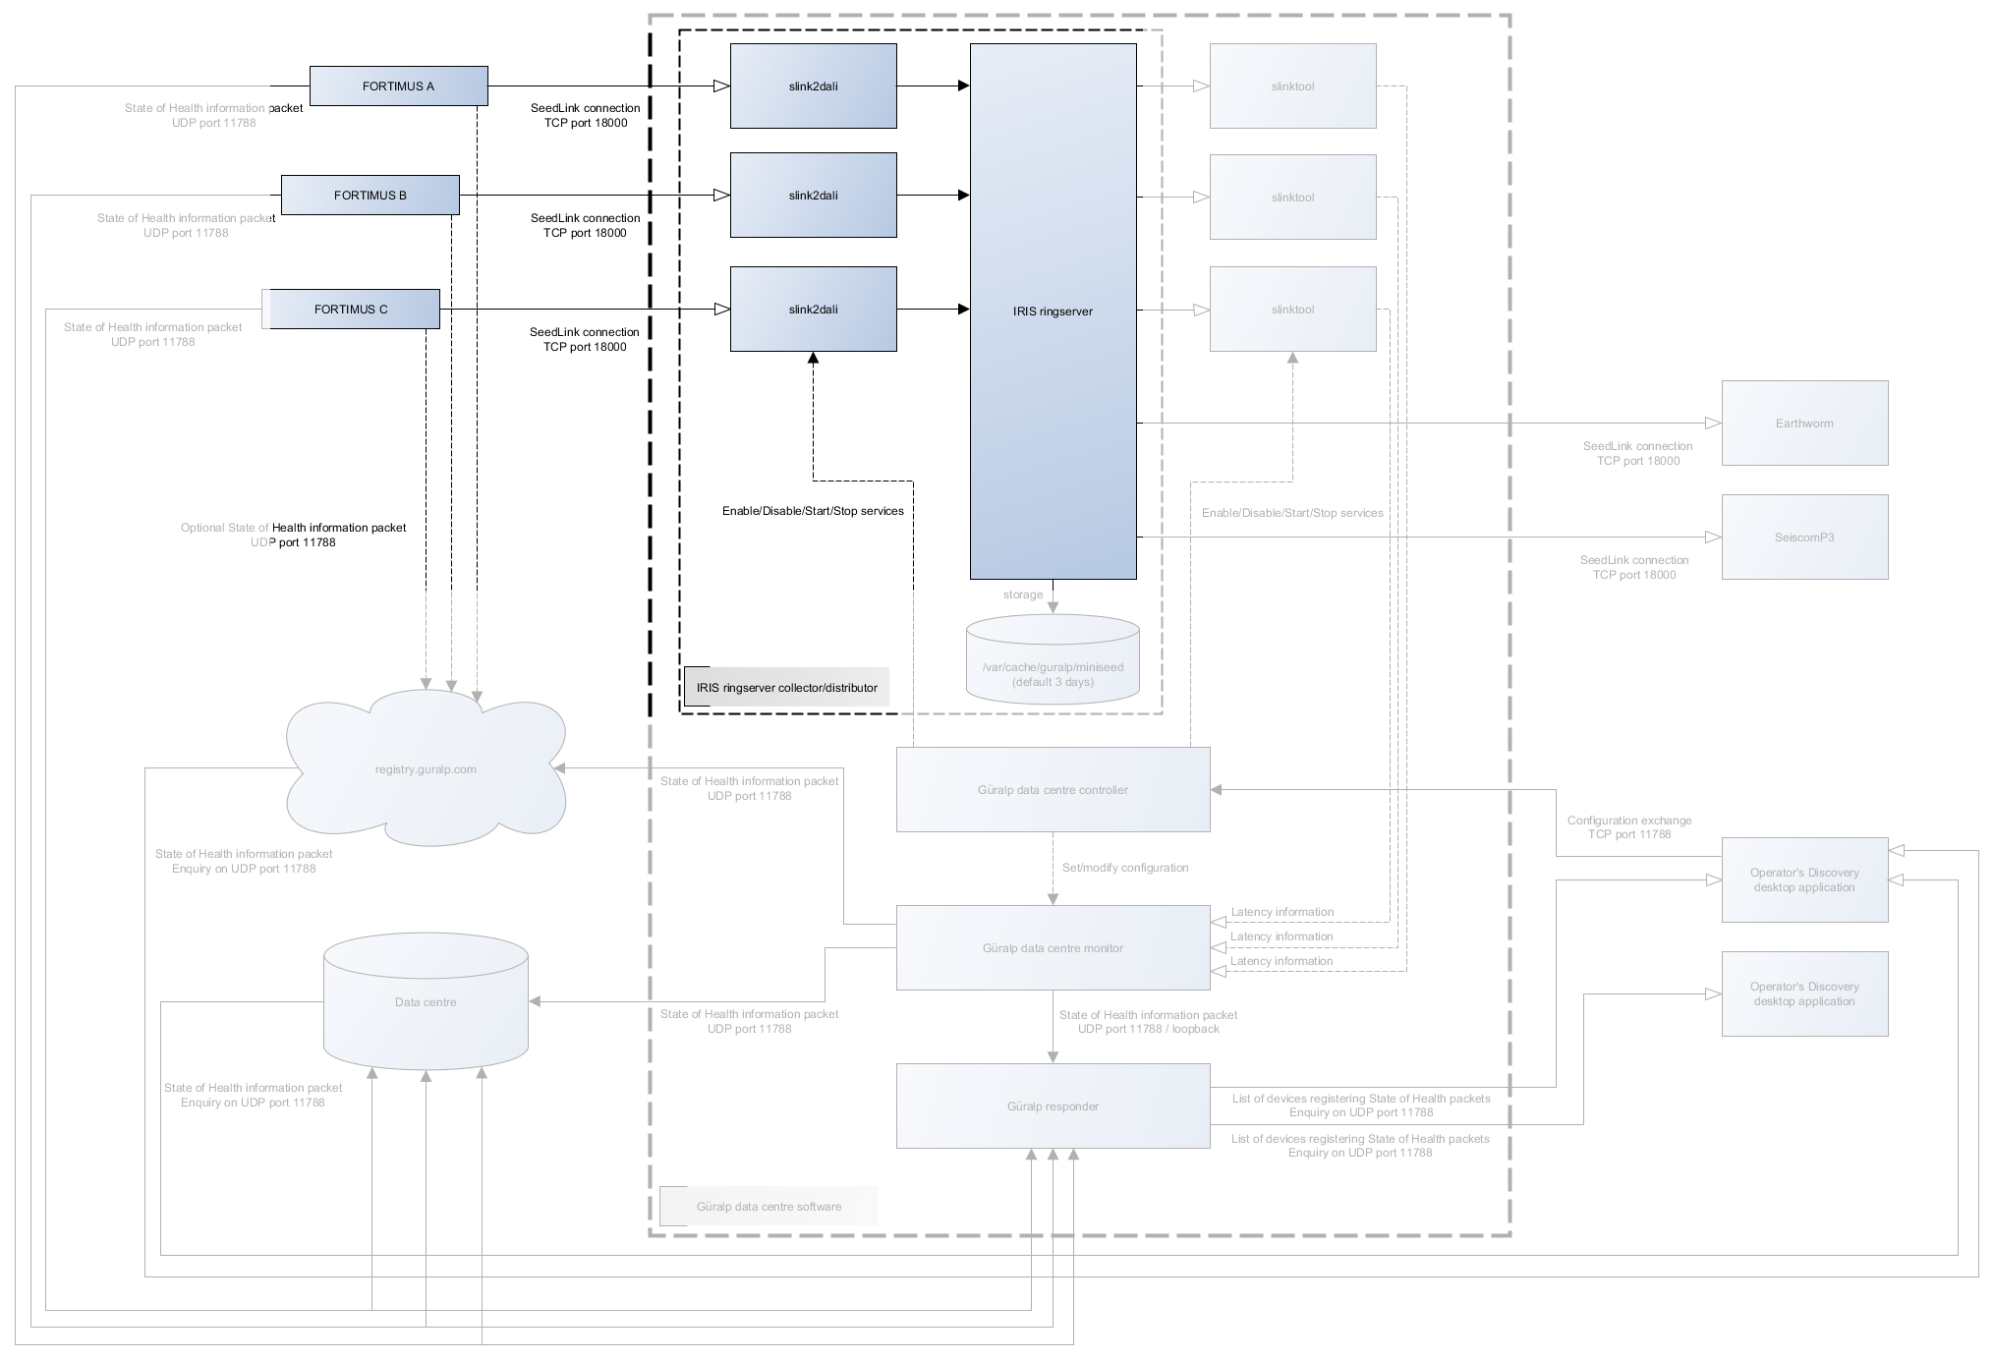

IRIS ringserver uses slink2dali service to collect the data from the seismic station. Data is collected using SeedLink protocol through TCP connection on port 18000. Data acquisition for a given station can be started either remotely through Discovery desktop application, or manually by enabling/starting slink2dali service for the station when logged into the Data Centre computer, more details on how to start a connection can be found in Güralp Data Centre Operator Manual.

## Data Distribution

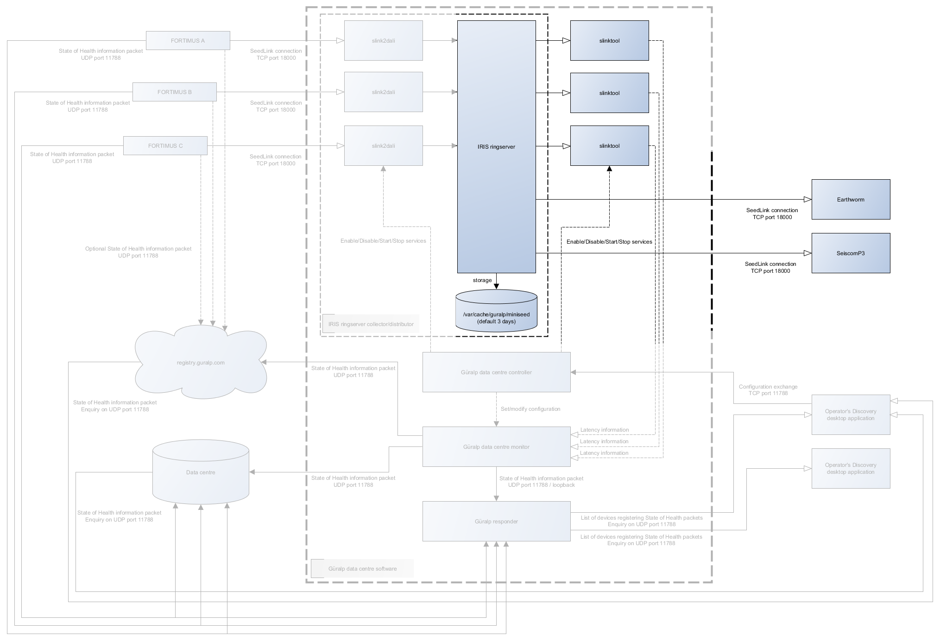

Data Centre data distribution is handled by IRIS ringserver and is provided as SeedLink and/or DataLink connection instantiated by the remote client on TCP link. Default port configuration is 16000 for DataLink and 18000 for SeedLink.

## Configuration management

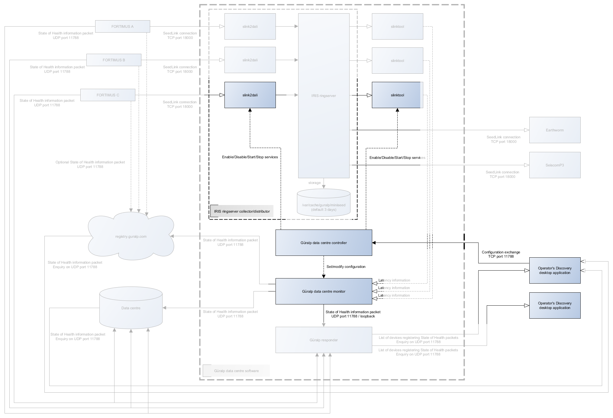

Configuration of Data Centre software package components can be done, under normal operation, by the Discovery desktop application. Discovery provides functionality to configure which seismic stations Data Centre should be connected to and what conditions should be used to generate state of health information. Configuration exchange is performed on port 11788 TCP connection between Data Centre and Discovery. Discovery requests the current configuration from the Data Centre, modifies it if required, and sends back the updated structure.

Extra configuration may be required during installation and the possible options are described in Güralp Data Centre Installation document.

## State of health

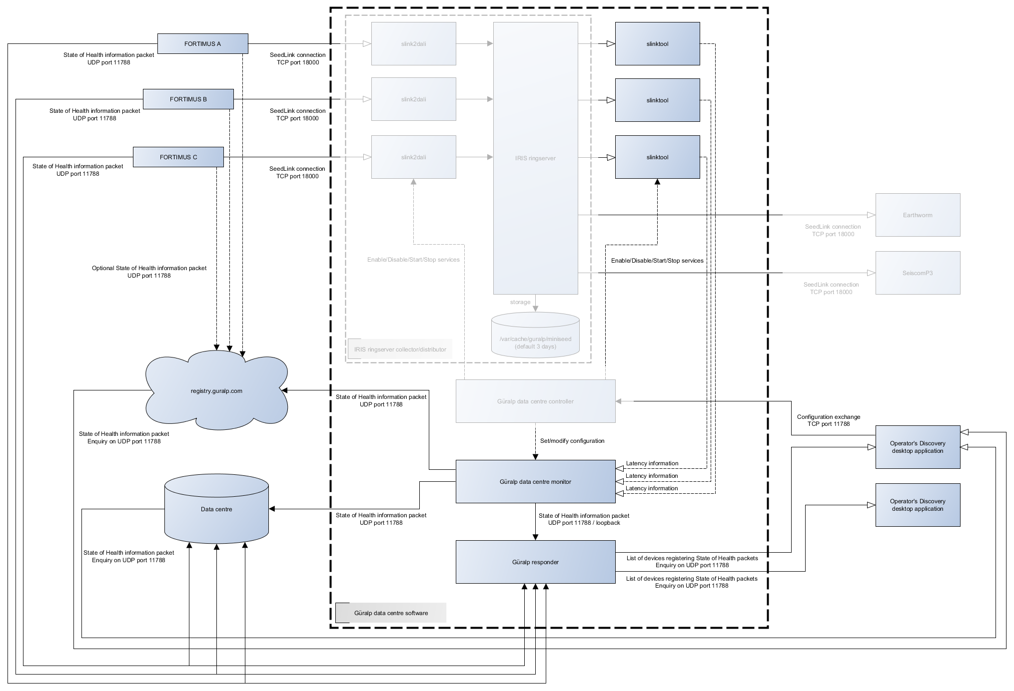

State of health information can be distributed to multiple registries by both, Güralp Data Centre Monitor service and Güralp seismic station on port 11788 through UDP packets. Information gathered from the system is packetized and sent to configured Güralp Responder servers to be redistributed on request.

State of health information is requested by Discovery desktop application from the registry and displayed in the application main window table. More detailed information about system status can be obtained by accessing either device dashboard (for seismic stations) or state of health dashboard (for data centre instance). More information about how to operate Discovery application can be found in Güralp Data Centre Operator Manual.

# 

# Summary

## Network protocols and ports

Güralp devices which are using DIG operating system require the following ports to be open/forwarded:

|  |  |  |
| --- | --- | --- |
| **Port** | **Protocol** | **Description** |
| 80 | TCP | HTTP server, required to access device webpage for state of health information and configuration. |
| 1565 | TCP | GDI data transmission protocol. |
| 1567 | TCP/UDP | GCF data transmission protocol. |
| 4242 | TCP | File exchange protocol used by Discovery desktop application to exchange files and configuration. |
| 4244 | TCP | Remote console used for debugging, available in Discovery desktop application. |
| 11788 | UDP | Remote procedure calls protocol used by the Discovery desktop application to remotely execute functions on the device.  This port is also an outgoing port for State of Health packets that are sent to the Güralp Responder server. |
| 18000 | TCP | SeedLink data transmission protocol. |

Data centre software package requires the following ports to be open:

|  |  |  |
| --- | --- | --- |
| **Port** | **Protocol** | **Description** |
| 11788 | UDP | Used for sending and requesting state of health information by system components and Discovery desktop application. |
| 11788 | TCP | Configuration exchange protocol used by Discovery desktop application to configure data streaming connections. |
| 16000 | TCP | DataLink data transmission protocol connection to IRIS ringserver. |
| 18000 | TCP | SeedLink data transmission protocol connection to IRIS ringserver for both incoming and outgoing data streams. |

# Version

|  |  |  |  |
| --- | --- | --- | --- |
| Version | Date | Author | Comment |
| 1 | 2021/08/03 | P Grabalski | Initial document uploaded |
| 2 | 2021/08/04 | P Grabalski | Ports and spelling corrections |