Güralp Data Centre

Installation guide

Contents

Installation guide 3

Introduction 3

Operating system requirements 3

Software package content 3

Installation 3

Install libmseed 3

Install slinktool 4

Install slink2dali 4

Install Güralp Data Centre software 4

Verification 4

Download 5

Documentation: 5

Software packages: 5

Support 5

Software packages diagram

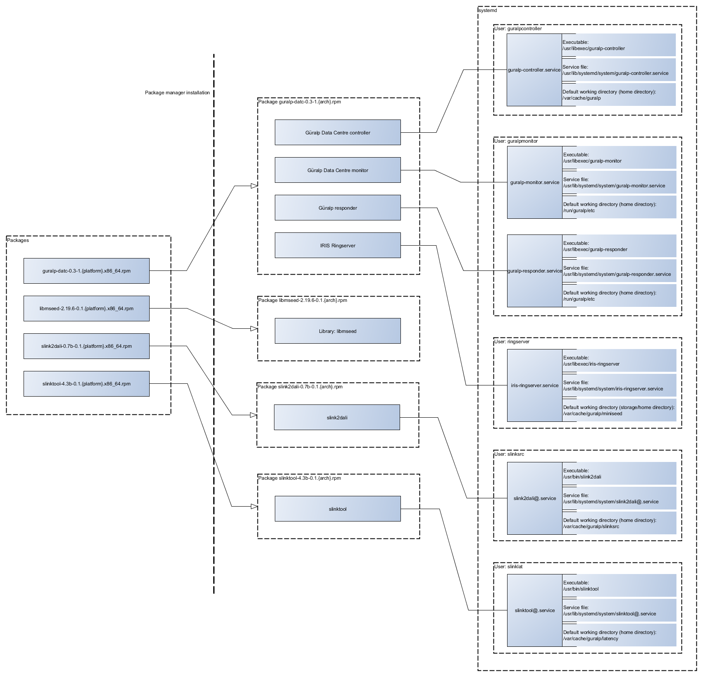

# Installation guide

## Introduction

This installation guideline provides instructions of how to install Güralp Data Centre acquisition software package with required dependencies. Software package is provided in a form of a set of RPM files that in this document are installed using dnf package manager on Red Hat 8.

## Operating system requirements

Güralp Systems Data Centre software package has been tested on the following x86_64 platforms:

* Red Hat Enterprise Linux 8 (or equivalent, e.g. Rocky Linux 8 or AlmaLinux 8)
* Amazon Linux 2

Minimum system dependency requirements are:

* systemd v239
* Qt v5.12.5
* polkit v0.115

## Software package content

Software package provided contains 4 RPM files:

* **guralp-datc-0.5-1.el8.x86_64.rpm**

Installs the main components of the Data Centre: IRIS ringserver, Güralp responder and the Data Centre controller and monitor binaries.

* **libmseed-2.19.6-0.1.el8.x86_64.rpm**

Installs libmseed library providing MiniSEED support for SEED related parts of the software solution.

* **slink2dali-0.7b-0.1.el8.x86_64.rpm**

Installs slink2dali executable required to convert SeedLink data received from the seismic station to DataLink data consumed by the IRIS ringserver.

* **slinktool-4.3b-0.1.el8.x86_64.rpm**

Installs slinktool executable required to measure the data latency.

## Installation

Software package is provided in a set of RPM files that should be installed using the operating system package manager. This document describes installation procedure on Red Hat Enterprise Linux 8 with dnf package manager.

Installation requires root privileges and access to the RedHat packages repository.

### Install libmseed

Install libmseed package from the provided RPM using dnf package manager by executing the following command:

sudo dnf install libmseed-2.19.6-0.1.el8.x86_64.rpm

### Install slinktool

Install slinktool package from the provided RPM using dnf package manager by executing the following command:

sudo dnf install slinktool-4.3b-0.1.el8.x86_64.rpm

### Install slink2dali

Install slink2dali package from the provided RPM using dnf package manager by executing the following command:

sudo dnf install slink2dali-0.7b-0.1.el8.x86_64.rpm

### Install Güralp Data Centre software

Install Güralp Data Centre software package from the provided RPM using dnf package manager by executing the following command:

sudo dnf install guralp-datc-0.5-1.el8.x86_64.rpm

### Verification

Each installation step should complete without failures and all of the required dependencies should be pulled from the package repository. Please contact Güralp support in case of any problems.

Successful installation should result in all of the key services to be enabled and running in the operating system what can be verified by executing the following commands:

* **For Güralp responder:**

systemctl status guralp-responder.service

Reported status should indicate the service is **active** and **running**.

* **For Güralp Data Centre monitor:**

systemctl status guralp-monitor.service

Reported status should indicate the service is **active** and **running**.

* **For Güralp Data Centre controller:**

systemctl status guralp-controller.service

Reported status should indicate the service is **active** and **running**.

* **For IRIS ringserver:**

systemctl status iris-ringserver.service

Reported status should indicate the service is **active** and **running**.

Additionally, slinktool and slink2dali binaries should be available under /usr/bin directory.

*Note: slinktool and slink2dali services are available per seismic station connection therefore installation process will not start those services automatically. In order to create a connection to the remote data server please refer to Güralp Data Centre Operator Manual.*

# Download

Software packages can be downloaded from Güralp website by following the links below.

## Documentation:

* Architecture overview: [docx](https://www.guralp.com/download/datc/documents/Guralp_Data_Centre_Architecture_Overview.docx) | [pdf](https://www.guralp.com/download/datc/documents/Guralp_Data_Centre_Architecture_Overview.pdf)
* Installation guideline: [docx](https://www.guralp.com/download/datc/documents/Guralp_Data_Centre_Installation_Guide.docx) | [pdf](https://www.guralp.com/download/datc/documents/Guralp_Data_Centre_Installation_Guide.pdf)
* Operator manual: [docx](https://www.guralp.com/download/datc/documents/Guralp_Data_Centre_Operator_Manual.docx) | [pdf](https://www.guralp.com/download/datc/documents/Guralp_Data_Centre_Operator_Manual.pdf)

## Software packages:

* Guralp Data Centre package [guralp-datc-0.5-1.*platform*.x86_64.rpm]:   
  [Red Hat Enterprise Linux 8](https://www.guralp.com/download/datc/guralp-datc-0.5-1.el8.x86_64.rpm) | [Amazon Linux 2](https://www.guralp.com/download/datc/guralp-datc-0.5-1.amzn2.x86_64.rpm)
* Slink2dali [slink2dali-0.7b-0.1.*platform*.x86_64.rpm]:   
  [Red Hat Enterprise Linux 8](https://www.guralp.com/download/datc/slink2dali-0.7b-0.1.el8.x86_64.rpm) | [Amazon Linux 2](https://www.guralp.com/download/datc/slink2dali-0.7b-0.1.amzn2.x86_64.rpm)
* Slinktool [slinktool-4.3b-0.1.*platform*.x86_64.rpm]:   
  [Red Hat Enterprise Linux 8](https://www.guralp.com/download/datc/slinktool-4.3b-0.1.el8.x86_64.rpm) | [Amazon Linux 2](https://www.guralp.com/download/datc/slinktool-4.3b-0.1.amzn2.x86_64.rpm)
* MiniSeed library [libmseed-2.19.6-0.1.*platform*.x86_64.rpm]:   
  [Red Hat Enterprise Linux 8](https://www.guralp.com/download/datc/libmseed-2.19.6-0.1.el8.x86_64.rpm) | [Amazon Linux 2](https://www.guralp.com/download/datc/libmseed-2.19.6-0.1.amzn2.x86_64.rpm)

# Support

For support enquiries, please contact [support@guralp.com](mailto:support@guralp.com).

Güralp Systems Limited  
Midas House, Calleva Park, Aldermaston,  
Reading, RG7 8EA,  
United Kingdom

Tel: +44 118 981 9056  
Fax: +44 118 981 9943

E-mail: sales@guralp.com